Web Development and OS Supporting Document

This document must be completed and uploaded as part of your submission for the Web Dev and OS assignment 2. This should also be brought to the demo for the assignment and will be marked during that demo

**Name Jamie Carson**

**Student ID 23035895**

**The link to your final web application (task 4 / 5) https://assignment-work-9e60f.web.app/index.html**

Add below all proof as requested in the assignment specification, update the contents table pages and upload this document with your submission.

No details are needed for task four and five as this will be shown at the demo

Contents

Task One 2

Task Two 3

Task Three 4

# Task One

**HTML – Tags**

|  |  |
| --- | --- |
| **Criteria** | **Location (page / line number)** |
| semantic tag for grouping the contents of the header | **Index.HTML Line 2 & Line 10** |
| heading at appropriate level | **Yes Line 4** |
| numbered list | **Line 26-33** |
| emphasised text | **Line 62** |
| hyperlink to anchor on an internal page | **Yes Line 100** |

**HTML - Images**

|  |  |
| --- | --- |
| **Criteria** | **Location (page / line number)** |
| img tag for image with suitable optimised format and alt text | **Index line 119** |
| picture tag with different images for mobile and desktop in a suitable, modern (e.g. AVIF, WEBP) optimised image format | **Index line 42** |
| picture tag fallback for older browsers | **Index line 42** |
| multi-resolution images (srcset) for different screen resolutions (NOT SVG) | **Index Line 44** |
| SVG image | **Index line 119** |
| HTML comments to show the source of the images | **118** |

# Task Two

**Screenshot of page, clearly showing your name**

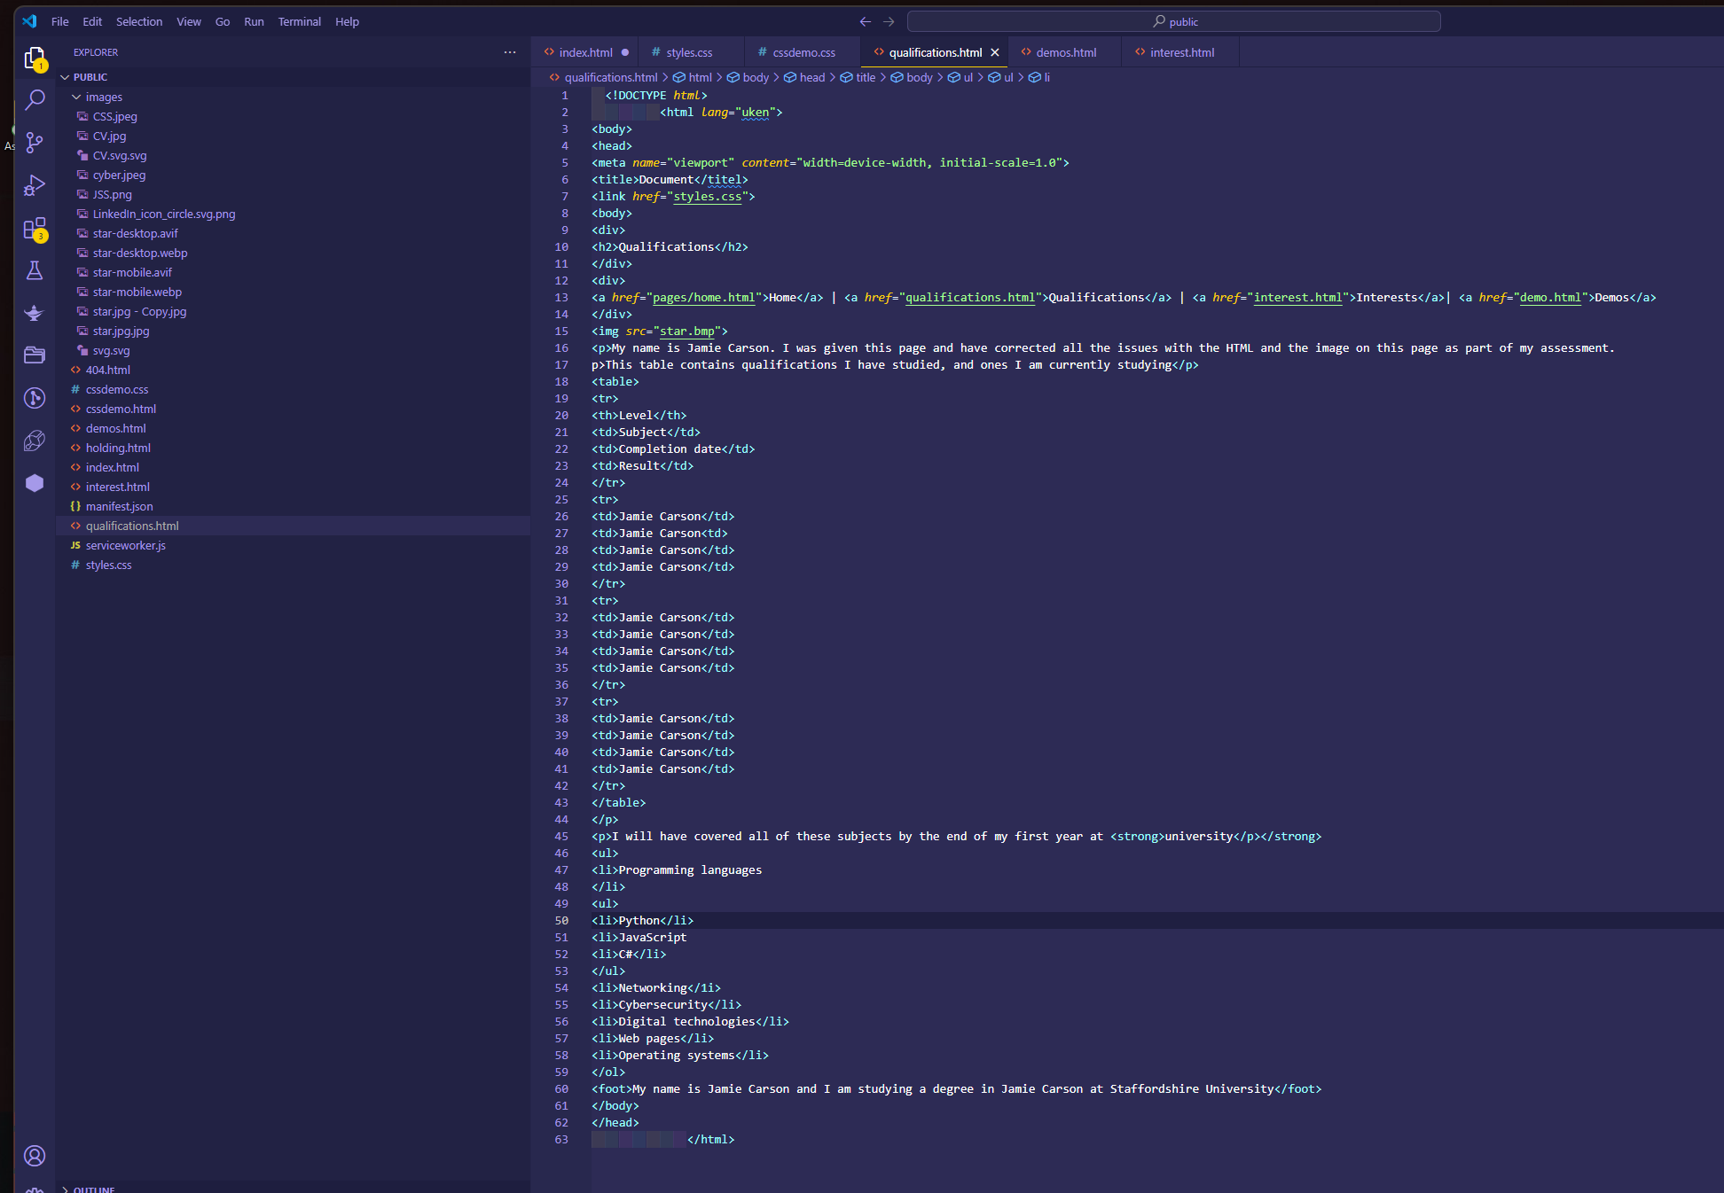

**Screenshot of initial validation, showing at least 5 errors**

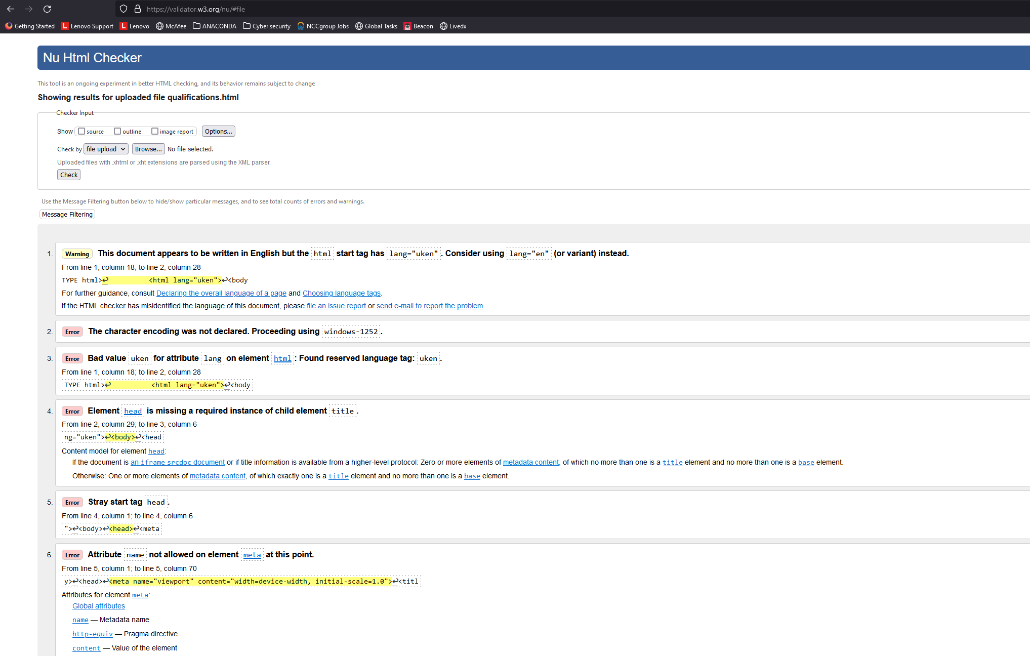

**5 of the changes you did to make the HTML valid**

|  |  |  |  |
| --- | --- | --- | --- |
| **Original error description** | **Original code** | **Corrected code** | **Description of correction** |
| html start tag has lang="uken". Consider using lang="en" (or variant) instead. | <html *lang*="uken"> | <html *lang*="en"> | **Deleted ‘uk’** |
| The character encoding was not declared. Proceeding using windows-1252 | **Code was missing** | <meta *charset*="UTF-8"> | **Declared charset** |
| Element [head](https://html.spec.whatwg.org/multipage/#the-head-element) is missing a required instance of child element title. | <title>Document</titel> | <title>Document</title> | **C**orrected “title” typo |
| Stray start tag head. | <body>    <head>      <meta *charset*="UTF-8">      <meta *name*="viewport" *content*="width=device-width, initial-scale=1.0">      <title>Document</title>        <link *href*="styles.css">    <body> | <body>    <head>      <meta *charset*="UTF-8">      <meta *name*="viewport" *content*="width=device-width, initial-scale=1.0">      <title>Document</title>        <link *href*="styles.css">    </head>  <body> | **A**dded head Tag in correct location |
| Attribute name not allowed on element [meta](https://html.spec.whatwg.org/multipage/#the-meta-element) at this point. | <body>    <head>      <meta *charset*="UTF-8">      <meta *name*="viewport" *content*="width=device-width, initial-scale=1.0">      <title>Document</title>      <link *href*="styles.css">    </head>  <body> | <!DOCTYPE *html*>  <html *lang*="en">    <head>      <meta *charset*="UTF-8">      <meta *name*="viewport" *content*="width=device-width, initial-scale=1.0">      <title>Document</title>      <link *href*="styles.css">    </head>  <body>      <div>        <h2>Qualifications</h2> | **First body tag causes the issues, this is an additional body tag and is not needed** |

**Screenshot showing validation with no errors**

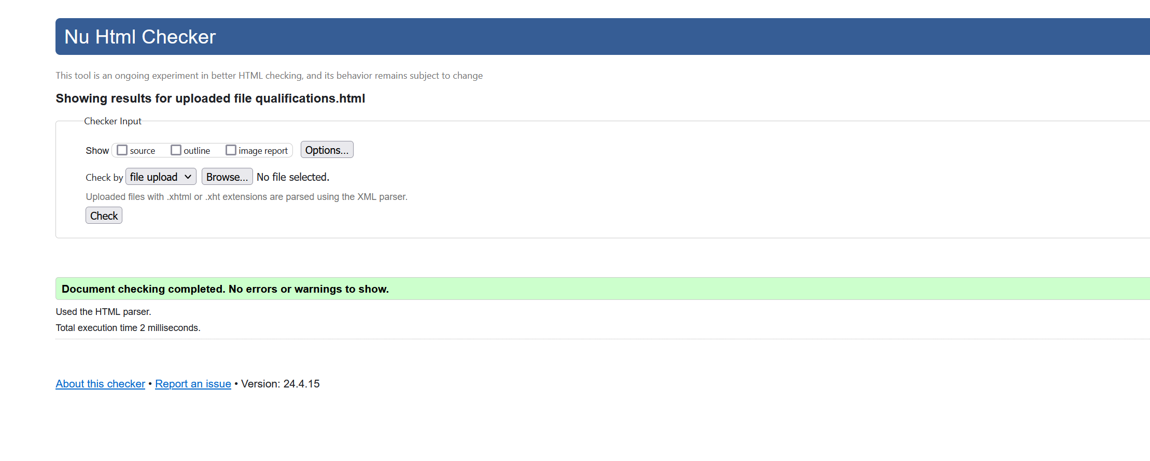

**Correction of the image**

|  |  |  |  |
| --- | --- | --- | --- |
| **New format** | **Original size (bytes)** | **Size after changes (bytes)** | **Changes made** |
| images/star-desktop.webp | **15.6kb** | **6.57kb** | **Converted to webp** |

**5 corrections made for good HTML practice**

|  |  |  |
| --- | --- | --- |
| **Original code** | **Correct code** | **Reason for change** |
| <h2>Qualifications</h2> | <h1>Qualifications</h1> | **H2 used instead of h1** |
| <div>      <h1>Qualifications</h1>    </div>    <div>      <a *href*="pages/home.html">Home</a> | <a *href*="qualifications.html">Qualifications</a> | <a  *href*="interest.html">Interests</a>| <a *href*="demo.html">Demos</a>    </div> | <header>      <div>        <h1>Qualifications</h1>      </div>      <div>        <a *href*="pages/home.html">Home</a> | <a *href*="qualifications.html">Qualifications</a> | <a *href*="interest.html">Interests</a>| <a *href*="demo.html">Demos</a>      </div>    </header> | **Used Header tag** |
| <p>Degrees modules</p>        <ol>        <li>Networking</li>        <li>Cybersecurity</li>        <li>Digital technologies</li>        <li>Web pages</li>        <li>Operating systems</li>      </ol> | <p>Degrees modules</p>      <div>        <ol>          <li>Networking</li>          <li>Cybersecurity</li>          <li>Digital technologies</li>          <li>Web pages</li>          <li>Operating systems</li>        </ol>      </div> | **Put lists in divs** |
| <div>      <a *href*="pages/home.html">Home</a> | <a *href*="qualifications.html">Qualifications</a> | <a  *href*="interest.html">Interests</a>| <a *href*="demo.html">Demos</a>    </div> | <nav>      <a *href*="pages/home.html">Home</a> | <a *href*="qualifications.html">Qualifications</a> | <a  *href*="interest.html">Interests</a>| <a *href*="demo.html">Demos</a>      </nav>    </div> | **Used nav tag for the navigation elements** |
| <div>      <nav>      <a *href*="pages/home.html">Home</a> | <a *href*="qualifications.html">Qualifications</a> | <a  *href*="interest.html">Interests</a>| <a *href*="demo.html">Demos</a>      </nav>    </div> | *<!-- Navigation elements -->*    <div>      <nav>      <a *href*="pages/home.html">Home</a> | <a *href*="qualifications.html">Qualifications</a> | <a  *href*="interest.html">Interests</a>| <a *href*="demo.html">Demos</a>      </nav>    </div> | **Added HTML comments for readbility** |
|  |  |  |
|  |  |  |

# Task Three

**Wireframe for mobile for home page**

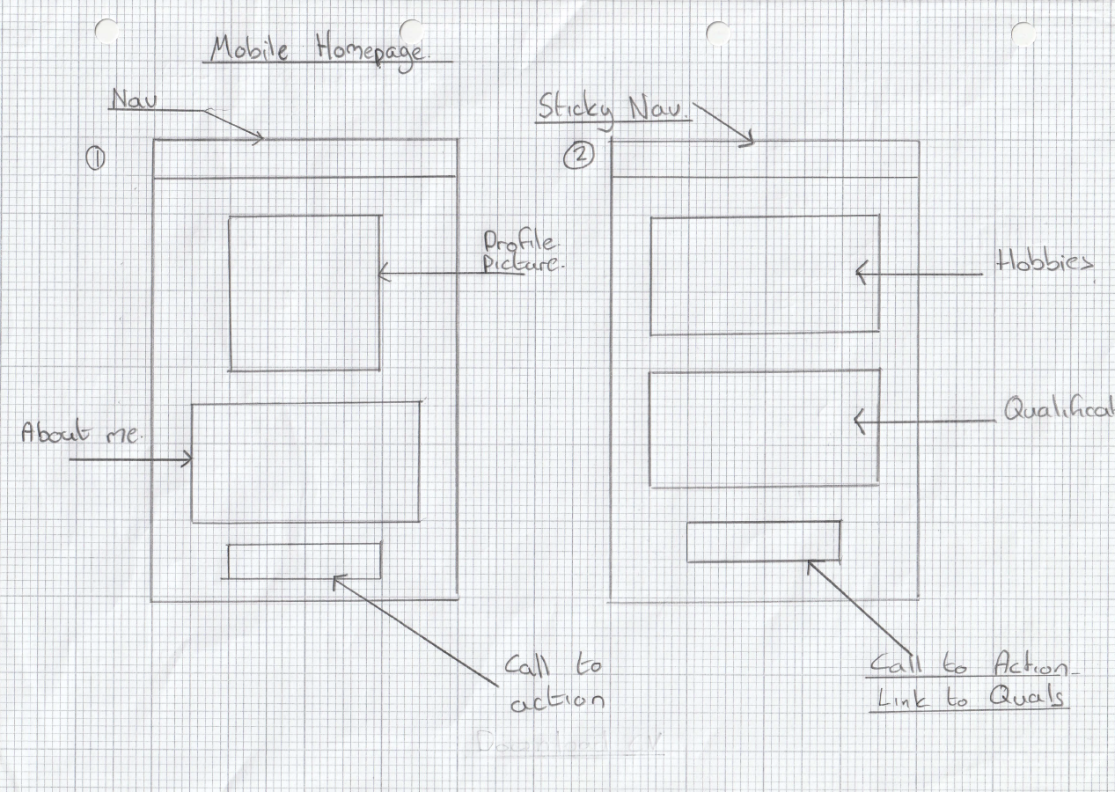

**Wireframe for desktop for home page (must be different than mobile)**

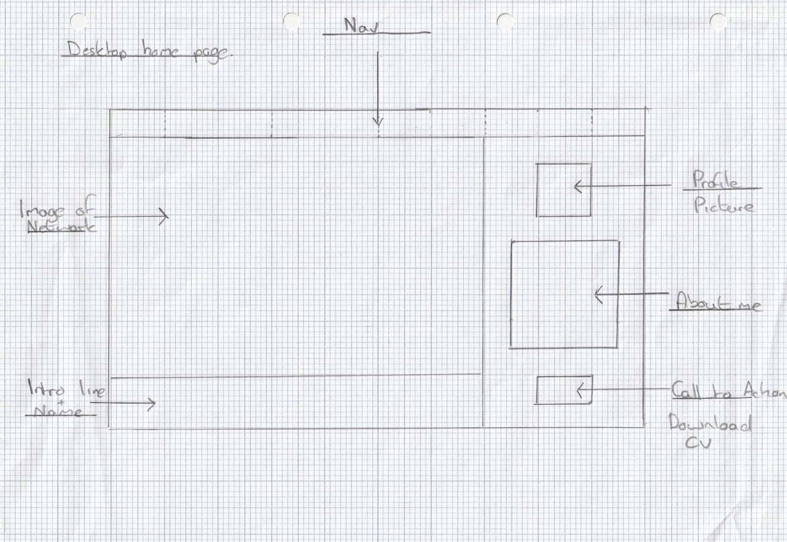

**Wireframe for mobile for CSS demo page**

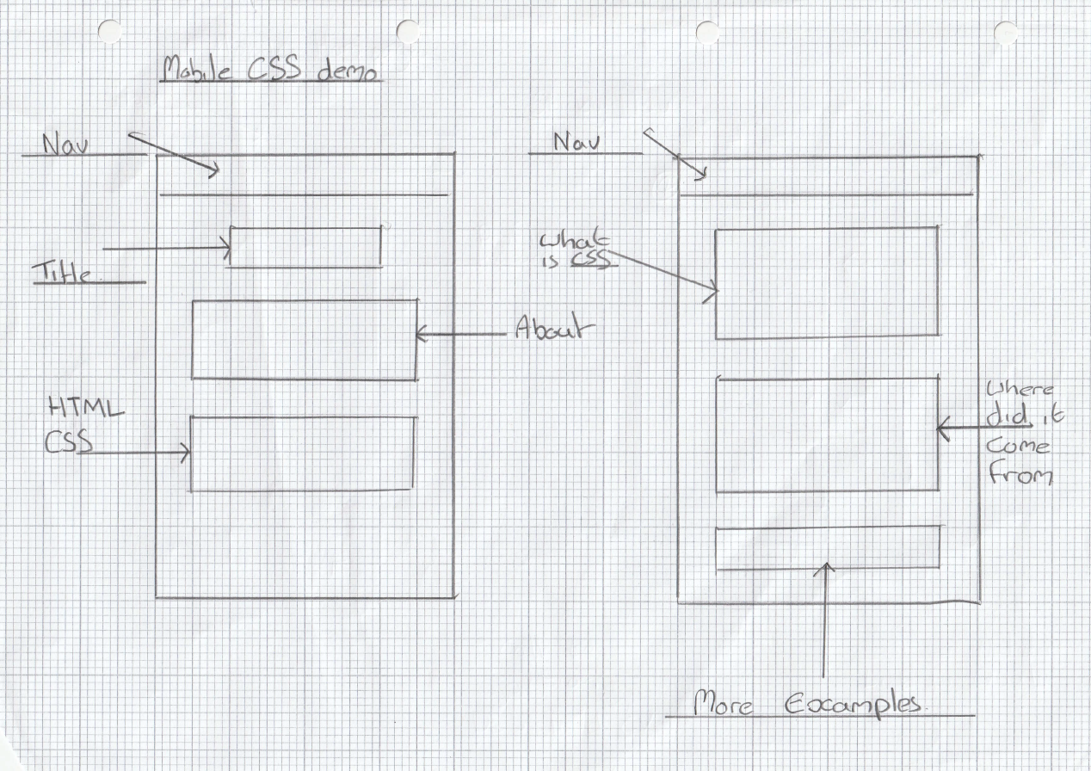

**Wireframe for desktop for CSS demo page (must be different than mobile)**

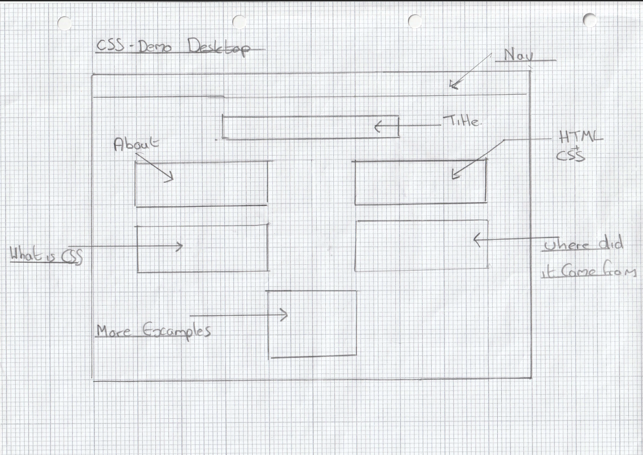

**CSS Skills**

|  |  |
| --- | --- |
| **criteria** | **Location (page / line number)** |
| flexbox containing at least 2 items | **Styles,289** |
| grid of at least 2x2 | **Styles 380** |
| element selector | **Styles 116** |
| ID selector | **Styles 56** |
| class selector | **Styles 159** |
| one other type of selector | **Styles 402** |
| alternative fonts to be used when the main one is not available | **Styles 116** |
| relative units of length, such as em | **Styles 170** |
| minimum and maximum width of the page | **Styles 320** |
| CSS comments to help the developer | **Styles 19** |
| overriding style from the mobile styles to the desktop styles in a media query | **Styles 320** |